Kinematics Graph Analysis

Use the graph provided to answer the questions that follow:

1.

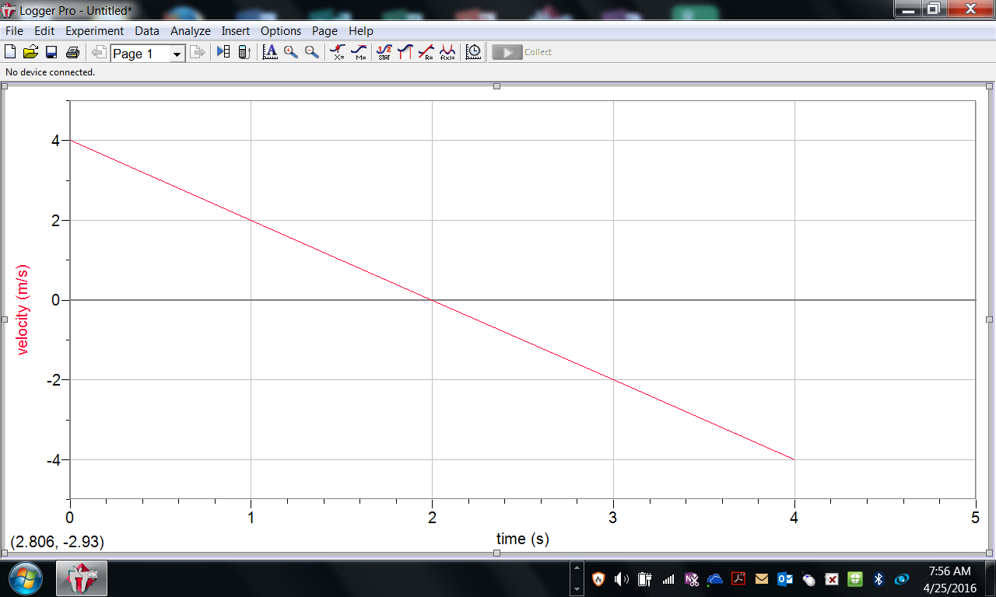

1. Which way is the object moving at t=1.0s? Is it gaining or losing speed then?
2. Which way is the object moving at t=3.0s? Is it gaining or losing speed then?
3. When, if ever does the object stop?
4. Determine the acceleration of the object. Show all five steps
5. Sketch the acceleration vs time graph.

2.

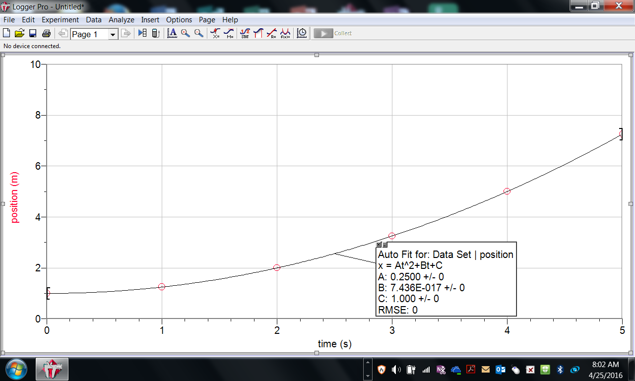

1. Which way is the object moving? Is it gaining or losing speed?
2. When, if ever does the object stop?
3. Determine the average velocity for the five second interval. Show all five steps
4. Sketch the velocity vs time graph.